1. Matplotlib Styles
Hasta ahora en este curso, hemos aprendido sobre el diseño y la narración de datos. En esta lección, vamos a centrar nuestra atención en los estilos predefinidos de Matplotlib. Para este caso de estudio, usaremos el estilo fivethirtyeight style para construir este gráfico.
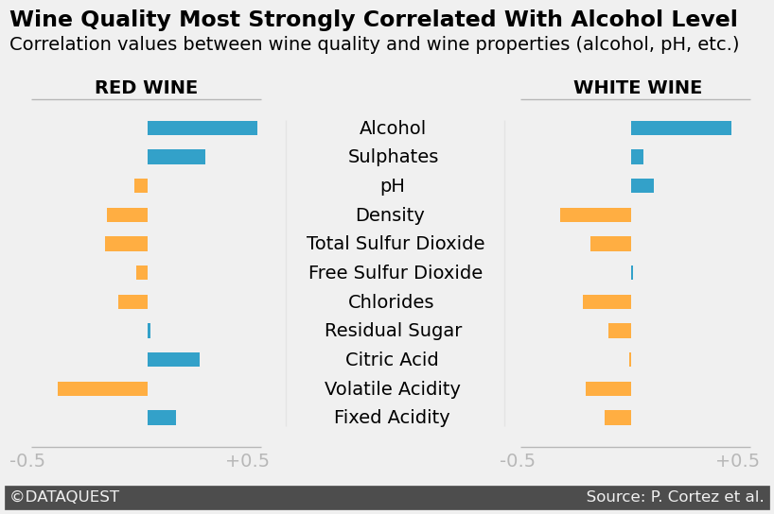
Matplotlib's pre-defined styles change the default visual properties of graphs. Below, we create a line plot using the Solarize_Light2 style. To do that, we import the matplotlib.style submodule and then use the style.use() function.
import matplotlib.pyplot as plt
import matplotlib.style as style

style.use('Solarize_Light2')
plt.plot([1, 2, 3], [5, 2, 7])
plt.show()
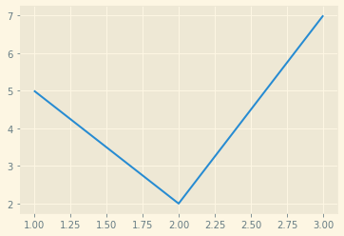
Note that we must use the style.use() function before we create the graph — before calling the plt.plot() function.
After we call style.use('Solarize_Light2'), all subsequent graphs will inherit this style. To get back to the default settings, we need to use style.use('default').
style.use('Solarize_Light2')
plt.plot([1, 2, 3], [5, 2, 7])
plt.show()

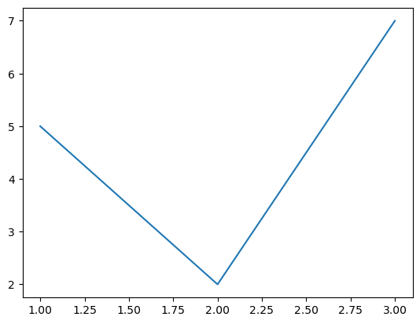
style.use('default')
plt.plot([1, 2, 3], [5, 2, 7])
plt.show()

We can see all the available styles by accessing the style.available attribute.
style.available
['Solarize_Light2',
'_classic_test_patch',
'bmh',
'classic',
'dark_background',
'fast',
'fivethirtyeight',
'ggplot',
'grayscale',
'seaborn',
'seaborn-bright',
'seaborn-colorblind',
'seaborn-dark',
'seaborn-dark-palette',
'seaborn-darkgrid',
'seaborn-deep',
'seaborn-muted',
'seaborn-notebook',
'seaborn-paper',
'seaborn-pastel',
'seaborn-poster',
'seaborn-talk',
'seaborn-ticks',
'seaborn-white',
'seaborn-whitegrid',
'tableau-colorblind10']

If you want to switch between different styles, use style.use('default') between each change — some of the styles can interfere with one another.
Now, let's practice what we learned.
Instructions
- Create a line plot using the ggplot style.
  - The x-coordinates are [2, 4, 6].
  - The y-coordinates are [10, 15, 5].
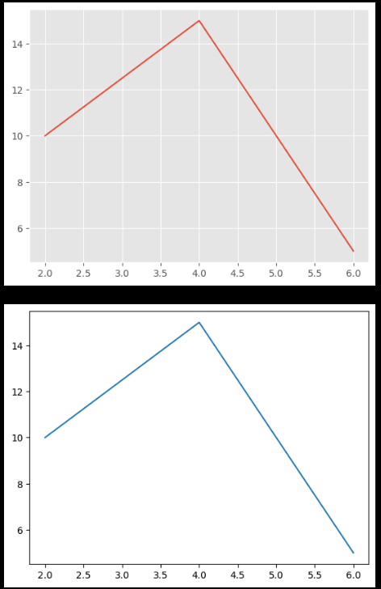
  - Close and display the plot using plt.show().
- Create a line plot using the default style.
  - The coordinates are the same as above.
  - Close and display the plot using plt.show().

import matplotlib.pyplot as plt
import matplotlib.style as style

style.use('ggplot')
plt.plot([2, 4, 6],[10, 15, 5])
plt.show()

style.use('default')
plt.plot([2, 4, 6],[10, 15, 5])
plt.show()

2. Wine Quality Dataset
We'll now take one Matplotlib style and build upon it — the fivethirtyeight style. We've already seen two FiveThirtyEight graphs in our previous lesson. You can see more of their graphs here.
We're going to use a dataset on wine quality. Researchers P. Cortez, A. Cerdeira, F. Almeida, T. Matos and J. Reis. collected this data for their research paper. We can find documentation and download the dataset from the UCI Machine Learning Repository.
The data comes in the form of two files:
- winequality-red.csv: data for red wine.
- winequality-white.csv: data for white wine.b
Below, we see the first five rows of the winequality-red.csv file:
import pandas as pd
red_wine = pd.read_csv('winequality-red.csv', sep=';')
red_wine.head()

 | fixed acidity | volatile acidity | citric acid | residual sugar | chlorides | free sulfur dioxide | total sulfur dioxide | density | pH | sulphates | alcohol | quality
0 | 7.4 | 0.70 | 0.00 | 1.9 | 0.076 | 11.0 | 34.0 | 0.9978 | 3.51 | 0.56 | 9.4 | 5
1 | 7.8 | 0.88 | 0.00 | 2.6 | 0.098 | 25.0 | 67.0 | 0.9968 | 3.20 | 0.68 | 9.8 | 5
2 | 7.8 | 0.76 | 0.04 | 2.3 | 0.092 | 15.0 | 54.0 | 0.9970 | 3.26 | 0.65 | 9.8 | 5
3 | 11.2 | 0.28 | 0.56 | 1.9 | 0.075 | 17.0 | 60.0 | 0.9980 | 3.16 | 0.58 | 9.8 | 6
4 | 7.4 | 0.70 | 0.00 | 1.9 | 0.076 | 11.0 | 34.0 | 0.9978 | 3.51 | 0.56 | 9.4 | 5

We want to determine which attributes (pH, alcohol level, etc.) most strongly correlate with wine quality. Below, we see the correlation values between quality and the other columns (if you need a recap or want to learn about correlation, this lesson offers a good introduction).
red_wine.corr()['quality'][:-1]
fixed acidity 0.124052
volatile acidity -0.390558
citric acid 0.226373
residual sugar 0.013732
chlorides -0.128907
free sulfur dioxide -0.050656
total sulfur dioxide -0.185100
density -0.174919
pH -0.057731
sulphates 0.251397
alcohol 0.476166
Name: quality, dtype: float64

Red wine quality most strongly correlates with alcohol level and volatile acidity. If you're curious, you can find information on the Internet on each wine property. In this article, for instance, we see that volatile acidity contributes to the smell and taste of vinegar in wine.
Let's now calculate correlations for the white wine dataset.
Instructions
- Read in the winequality-white.csv file into a pandas DataFrame.
  - Use sep=';' to properly read the file.
  - Assign the result to white_wine.
- Calculate the correlation between quality and the other columns of white_wine.
  - The result should be a pandas Series with the same structure as the Series resulted from red_wine.corr()['quality'][:-1].
  - Assign the correlation values to white_corr.
- Examine the correlation values — what are the strongest two correlations? How does this compare to the red wine values?
red_corrSeries (<class 'pandas.core.series.Series'>)  quality  alcohol 0.476166  sulphates 0.251397  citric acid 0.226373  fixed acidity 0.124052  residual sugar 0.013732  free sulfur dioxide-0.050656pH-0.057731  chlorides-0.128907  density-0.174919  total sulfur dioxide-0.185100  volatile acidity-0.390558 | white_corrSeries (<class 'pandas.core.series.Series'>)  quality  alcohol 0.435575  pH 0.099427  sulphates 0.053678  free sulfur dioxide 0.008158  citric acid -0.009209  residual sugar -0.097577  fixed acidity -0.113663  total sulfur dioxide -0.174737  volatile acidity -0.194723  chlorides -0.209934  density -0.307123

3.FiveThirtyEight Style
Previously, we calculated the correlation values between wine quality and wine properties. We want to represent these values visually in the form of two bar plots. Below, you can see what we want to build.
Let's start by creating the two bar plots using the fivethirtyeight style.
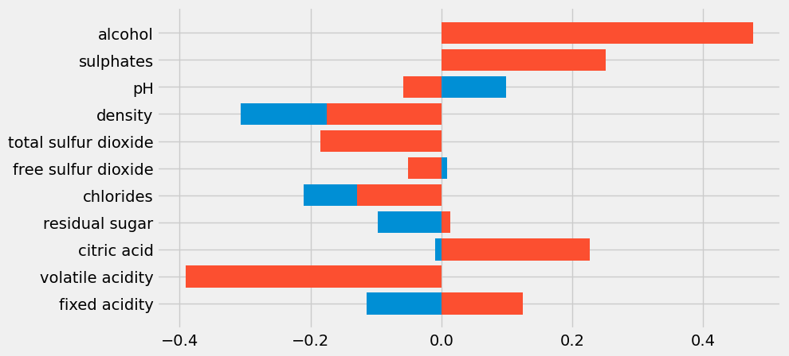

style.use('fivethirtyeight')
fig, ax = plt.subplots(figsize=(9, 5))
ax.barh(white_corr.index, white_corr)
ax.barh(red_corr.index, red_corr)
plt.show()

Podemos decir por los dos colores que Matplotlib construyó dos gráficos de barras diferentes. Sin embargo, no está claro cuál es cuál.
Para separarlos, vamos a mover el gráfico del vino blanco al lado derecho del gráfico. Para ello, podemos utilizar el parámetro izquierdo del método Axes.barh().
Este parámetro mueve los lados izquierdos de las barras desde su coordenada x por defecto de 0. En nuestro caso, left=2 las mueve de 0 a 2 (para las barras que representan cantidades negativas, los lados derechos se mueven de 0 a 2).
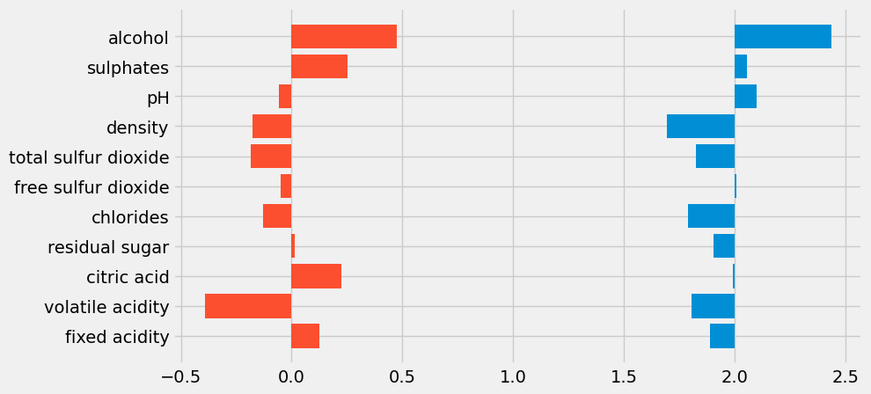

# Assume the other code is written
ax.barh(white_corr.index, white_corr, left=2)
ax.barh(red_corr.index, red_corr)

Basándonos en el principio de proximidad, ahora vemos dos gráficos de barras diferentes: el gráfico del vino tinto a la derecha (de color rojo), y el del vino blanco a la izquierda (de color azul).
Para maximizar la relación datos-tinta, ahora vamos a borrar lo siguiente:
- La tinta de los no datos
- Tinta de datos redundante
Aunque no veas el código, fíjate que se han quedado guardados de la pantalla anterior: red_wine, white_wine, red_corr, white_corr.

Instructions
- Remove the grid of the graph using the Axes.grid()method. Read the documentation to find the parameter you need to use.
- Remove the x- and y-tick labels. Use theAxes.set_xticklabels()methodand theAxes.set_yticklabels()method.
- Reduce the width of each bar to0.5by using theAxes.barh()method — you'll need to use the heightparameter.
# Initial Code

style.use('fivethirtyeight')
fig, ax = plt.subplots(figsize=(9, 5))
# ax.barh(white_corr.index, white_corr, left=2)
# ax.barh(red_corr.index, red_corr)
# *** *** *** *** *** *** *** *** *** ***
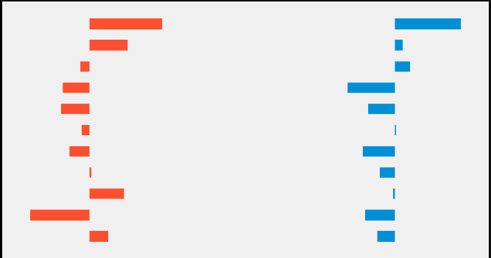
# Solution Code
ax.barh(white_corr.index, white_corr, left=2, height=0.5)
ax.barh(red_corr.index, red_corr, height=0.5)

ax.grid(b=False)
ax.set_yticklabels([])
ax.set_xticklabels([])

plt.show()

4.Adding Y-tick Labels
In the previous exercise, we erased the grid and the x- and y-tick labels, and we reduced the width of the bars. We'll now focus on adding structural elements so the audience can read the graph.
We begin by adding y-tick labels in the center of the graph — both bar plots have the same y-tick labels. Below, we add the labels usingAxes.text()and specify the coordinates manually. This can be a bit cumbersome, but it also gives us the precision and flexibility we need.
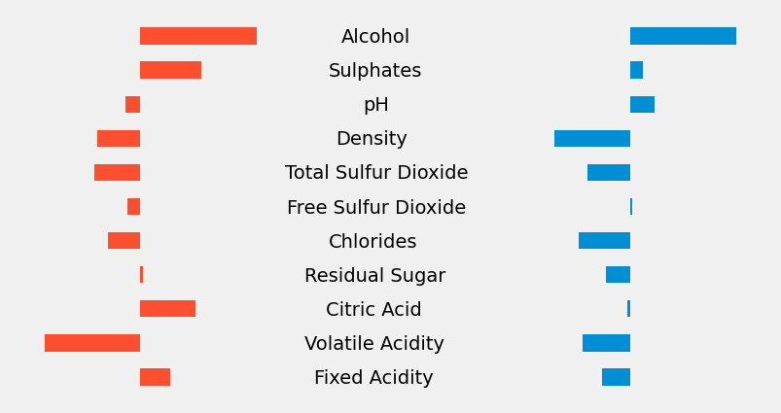
# Assume the rest of the code is written
x_coords = {'Alcohol': 0.82, 'Sulphates': 0.77, 'pH': 0.91,
'Density': 0.80, 'Total Sulfur Dioxide': 0.59,
'Free Sulfur Dioxide': 0.6, 'Chlorides': 0.77,
'Residual Sugar': 0.67, 'Citric Acid': 0.76,
'Volatile Acidity': 0.67, 'Fixed Acidity': 0.71}
y_coord = 9.8

for y_label, x_coord in x_coords.items():
ax.text(x_coord, y_coord, y_label)
y_coord -= 1

To create more space between the labels and each bar plot, we'll move the red wine bar plot a little to the left. We'll useleft=-0.1— this moves the x-coordinate of the left sides of the bars from0to-0.1.
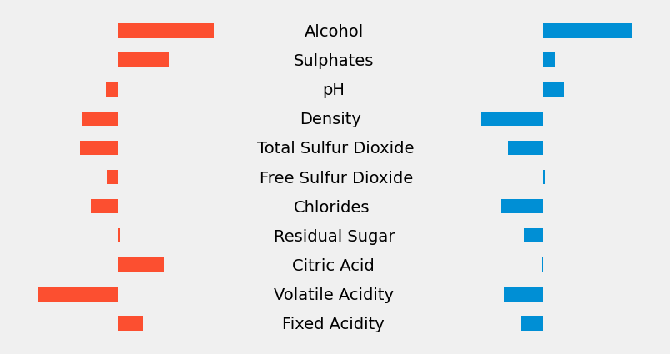
# Assume the rest of the code is written
ax.barh(red_corr.index, red_corr, height=0.5, left=-0.1)

To visually separate the labels from the bar plots, we're going to add two vertical lines — one to the left of the labels column, and the other to the right, like this:
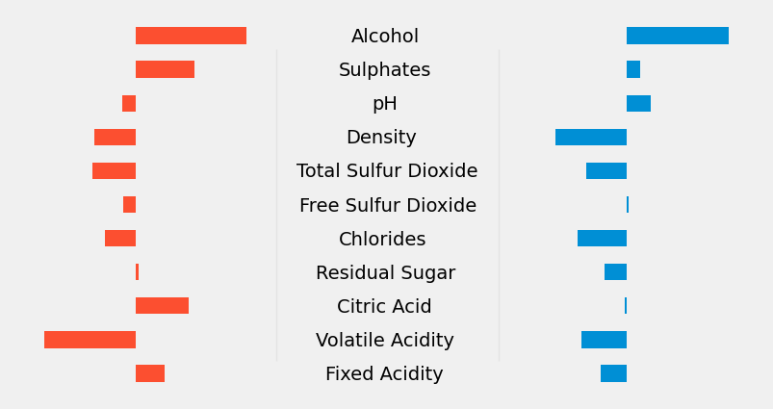
Instructions
Using theAxes.axvline()method:
- Add a vertical line to the left of the labels column. The line should have the following properties:
  - The x-coordinate is0.5.
  - The color isgrey.
  - Thealphavalue is0.1.
  - The line width is1.
  - Theyminis0.1and theymaxis0.9.
- Add a vertical line to the right of the labels column. The line should have the following properties:
  - The x-coordinate is1.45.
  - The color isgrey.
  - Thealphavalue is0.1.
  - The line width is1.
  - Theyminis0.1and theymaxis0.9.
style.use('fivethirtyeight')
fig, ax = plt.subplots(figsize=(9, 5))
ax.barh(white_corr.index, white_corr, left=2, height=0.5)
ax.barh(red_corr.index, red_corr, height=0.5, left=-0.1)

ax.grid(b=False)
ax.set_yticklabels([])
ax.set_xticklabels([])

x_coords = {'Alcohol': 0.82, 'Sulphates': 0.77, 'pH': 0.91,
'Density': 0.80, 'Total Sulfur Dioxide': 0.59,
'Free Sulfur Dioxide': 0.6, 'Chlorides': 0.77,
'Residual Sugar': 0.67, 'Citric Acid': 0.76,
'Volatile Acidity': 0.67, 'Fixed Acidity': 0.71}
y_coord = 9.8
for y_label, x_coord in x_coords.items():
ax.text(x_coord, y_coord, y_label)
y_coord -= 1
########################## codigo añadido ##########################
ax.axvline(x = 0.5 ,ymin = 0.1 , ymax = 0.9, alpha = 0.1, color = 'grey' )
ax.axvline(x = 1.45 ,ymin = 0.1 , ymax = 0.9, alpha = 0.1, color = 'grey' )
plt.show()

5.Adding X-tick Labels
On the previous screen, we focused on adding y-tick labels. Now, we need to add x-tick labels so the audience can read the correlation values.
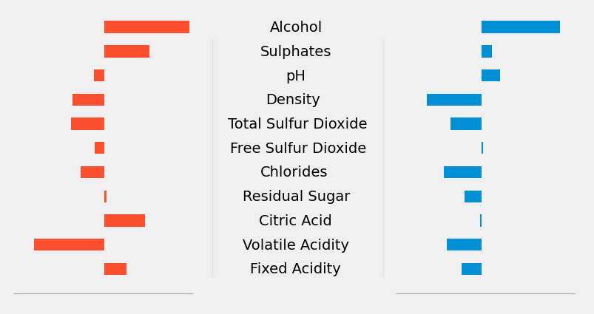
To do that, we're going to add a horizontal line under each bar plot. Note that we control the position of the lines along the x-axis through thexminand thexmaxparameters.
# Assume the rest of the code is written
ax.axhline(-1, color='grey', linewidth=1, alpha=0.5,
xmin=0.01, xmax=0.32)
ax.axhline(-1, color='grey', linewidth=1, alpha=0.5,
xmin=0.67, xmax=0.98)

All correlations range between -0.5 and +0.5, and we're going to use these two values as extremes.
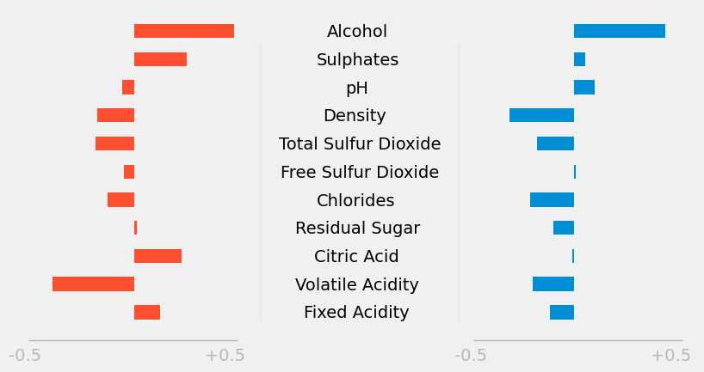
We're going to add these values as x-tick labels under each horizontal line. Below, note that we also use string concatenation (and' '*31means31space characters).
# Assume the rest of the code is written
ax.text(-0.7, -1.7, '-0.5'+ ' '*31 + '+0.5',
color='grey', alpha=0.5)
ax.text(1.43, -1.7, '-0.5'+ ' '*31 + '+0.5',
color='grey', alpha=0.5)

Now, we're going to add a title to each bar plot to show which is the plot for red wine and which is the other. To do that, we're going to draw a horizontal line above each plot. Then, we'll write"RED WINE"and"WHITE WINE"respectively above the horizontal lines.
Instructions
style.use('fivethirtyeight')
fig, ax = plt.subplots(figsize=(9, 5))
ax.barh(white_corr.index, white_corr, left=2, height=0.5)
ax.barh(red_corr.index, red_corr, height=0.5, left=-0.1)

ax.grid(b=False)
ax.set_yticklabels([])
ax.set_xticklabels([])

x_coords = {'Alcohol': 0.82, 'Sulphates': 0.77, 'pH': 0.91,
'Density': 0.80, 'Total Sulfur Dioxide': 0.59,
'Free Sulfur Dioxide': 0.6, 'Chlorides': 0.77,
'Residual Sugar': 0.67, 'Citric Acid': 0.76,
'Volatile Acidity': 0.67, 'Fixed Acidity': 0.71}
y_coord = 9.8
for y_label, x_coord in x_coords.items():
ax.text(x_coord, y_coord, y_label)
y_coord -= 1

ax.axvline(0.5, c='grey', alpha=0.1, linewidth=1,
ymin=0.1, ymax=0.9)
ax.axvline(1.45, c='grey', alpha=0.1, linewidth=1,
ymin=0.1, ymax=0.9)

ax.axhline(-1, color='grey', linewidth=1, alpha=0.5,
xmin=0.01, xmax=0.32)
ax.text(-0.7, -1.7, '-0.5'+ ' '*31 + '+0.5',
color='grey', alpha=0.5)
ax.axhline(-1, color='grey', linewidth=1, alpha=0.5,
xmin=0.67, xmax=0.98)
ax.text(1.43, -1.7, '-0.5'+ ' '*31 + '+0.5',
color='grey', alpha=0.5)

- Add a horizontal line above the red bar plot. The line should have the following properties:
  - The y-coordinate is 11.
  - The color isgrey.
  - The line width is 1.
  - Thealphavalue is0.5.
  - Thexminis0.01, and thexmaxis0.32.
- Add the text RED WINE above the horizontal line you've just built. The text should have the following properties:
  - Its coordinates are-0.33(x) and11.2(y).
  - It's bolded.
- Add a horizontal line above the blue bar plot. The line should have the following properties:
  - The y-coordinate is11.
  - The color isgrey.
  - The line width is1.
  - Thealphavalue is0.5.
  - Thexminis0.67, and thexmaxis0.98.
- Add the text WHITE WINE above the horizontal line you've just built. The text should have the following properties:
  - Its coordinates are1.75(x) and11.2(y).
  - It's bolded.

ax.axhline(11, color='grey', linewidth=1, alpha=0.5,
xmin=0.67, xmax=0.98)

ax.axhline(11, color='grey', linewidth=1, alpha=0.5,
xmin=0.01, xmax=0.32)

ax.text(-0.33, 11.2, 'RED WINE',
color='grey', alpha=0.5, weight = 'bold')

ax.text(1.75, 11.2, 'WHITE WINE',
color='grey', alpha=0.5, weight = 'bold')

plt.show()

6.Adding a Signature
FiveThirtyEight graphs generally have a signature bar at the bottom, where we see the creator's name and the data source.
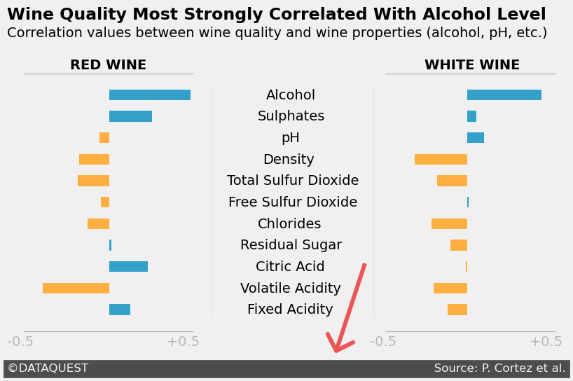
Matplotlib doesn't provide us with a function dedicated to generating signature bars. Again, we need to be creative and use the existing tools in creative ways.
One way to draw a signature bar is to add text with a dark background color. Below, we add the text©DATAQUEST Source: P. Cortez et al.with a background color of#4d4d4d(a shade of grey). The text itself has the color#f0f0f0, which is the same as the graph's background color.

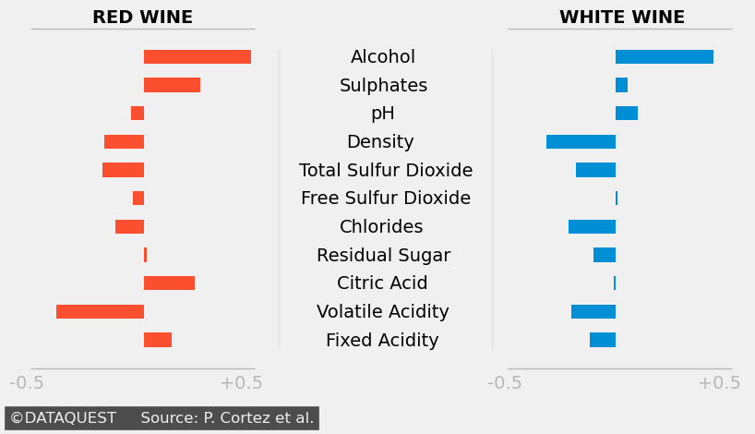

# Assume the rest of the code is written
ax.text(-0.7, -2.9,
'©DATAQUEST Source: P. Cortez et al.',
color = '#f0f0f0',
backgroundcolor = '#4d4d4d',
size=12)

To create the visual effect of a signature, we need to add more white space between©DATAQUESTandSource: P. Cortez et al.. We can use multiplication to add multiple white spaces —' '*94adds 94 white spaces.
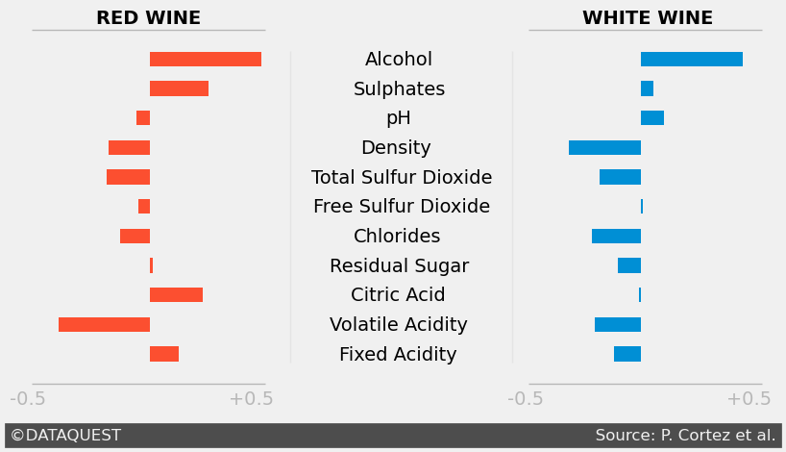
# Assume the rest of the code is written
ax.text(-0.7, -2.9,
'©DATAQUEST' + ' '*94 + 'Source: P. Cortez et al.',
color = '#f0f0f0',
backgroundcolor = '#4d4d4d',
size=12)

*espacio entre dataquest y ‘source’
Note that we perceive the creator's name and the data source as grouped together. They are part of the same group (part of the signature) thanks to the enclosure we create with the dark grey rectangle.
Let's now add a title and a subtitle to our graph. To maximize data-ink, we're going to do the following:
- We'll use the title to show data.
- We'll use the subtitle to explain the numerical values.
Instructions
style.use('fivethirtyeight')
fig, ax = plt.subplots(figsize=(9, 5))
ax.barh(white_corr.index, white_corr, left=2, height=0.5)
ax.barh(red_corr.index, red_corr, height=0.5, left=-0.1)

ax.grid(b=False)
ax.set_yticklabels([])
ax.set_xticklabels([])

x_coords = {'Alcohol': 0.82, 'Sulphates': 0.77, 'pH': 0.91,
'Density': 0.80, 'Total Sulfur Dioxide': 0.59,
'Free Sulfur Dioxide': 0.6, 'Chlorides': 0.77,
'Residual Sugar': 0.67, 'Citric Acid': 0.76,
'Volatile Acidity': 0.67, 'Fixed Acidity': 0.71}
y_coord = 9.8
for y_label, x_coord in x_coords.items():
ax.text(x_coord, y_coord, y_label)
y_coord -= 1

ax.axvline(0.5, c='grey', alpha=0.1, linewidth=1,
ymin=0.1, ymax=0.9)
ax.axvline(1.45, c='grey', alpha=0.1, linewidth=1,
ymin=0.1, ymax=0.9)

ax.axhline(-1, color='grey', linewidth=1, alpha=0.5,
xmin=0.01, xmax=0.32)
ax.text(-0.7, -1.7, '-0.5'+ ' '*31 + '+0.5',
color='grey', alpha=0.5)
ax.axhline(-1, color='grey', linewidth=1, alpha=0.5,
xmin=0.67, xmax=0.98)
ax.text(1.43, -1.7, '-0.5'+ ' '*31 + '+0.5',
color='grey', alpha=0.5)

ax.axhline(11, color='grey', linewidth=1, alpha=0.5,
xmin=0.01, xmax=0.32)
ax.text(-0.33, 11.2, 'RED WINE', weight='bold')
ax.axhline(11, color='grey', linewidth=1, alpha=0.5,
xmin=0.67, xmax=0.98)
ax.text(1.75, 11.2, 'WHITE WINE', weight='bold')

ax.text(-0.7, -2.9,
'©DATAQUEST' + ' '*94 + 'Source: P. Cortez et al.',
color = '#f0f0f0', backgroundcolor = '#4d4d4d',
size=12)

- Add the title Wine Quality Most Strongly Correlated With Alcohol Level. The title should have the following properties:
  - Its coordinates are-0.7(x) and13.5(y).
  - The size is17.
  - It's bolded.

- Add the subtitleCorrelation values between wine quality and wine properties (alcohol, pH, etc.). Its coordinates are-0.7(x) and12.7(y). Leave the font size on default.

ax.text(-0.7, 13.5, 'Wine Quality Most Strongly Correlated With Alcohol Level',
size=17, weight='bold')

ax.text(-0.7, 12.7, 'Correlation values between wine quality and wine properties (alcohol, pH, etc.)', size=12)

plt.show()
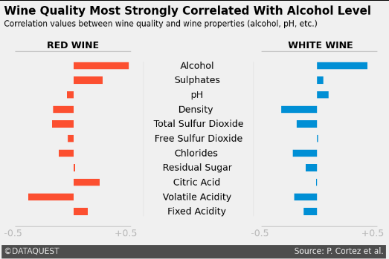
7.Coloring Bars Differently
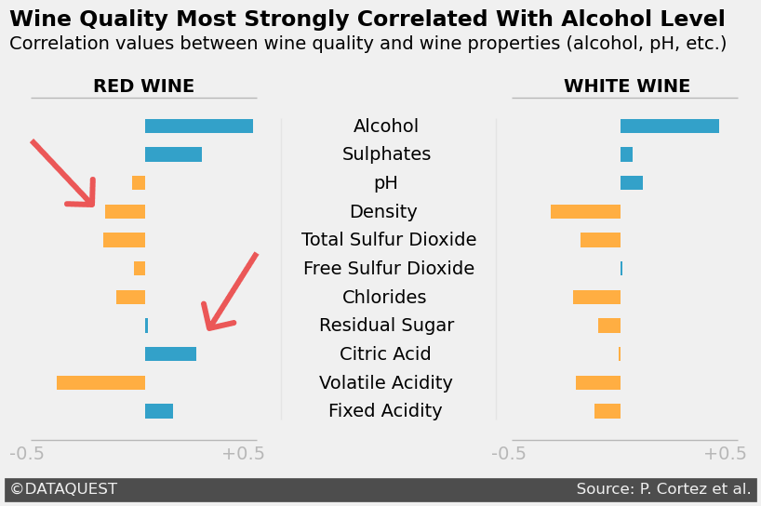
The last change we're going to make to our graph is the bar colors:
- Positive correlation values will take the color#33A1C9(a tint of blue).
- Negative correlation values will take the color#ffae42(a tint of orange).

To make this change, we'll use the color parameter of Axes.barh(). So far, we've only used strings with this parameter:'blue','red','#b00b1e', etc.

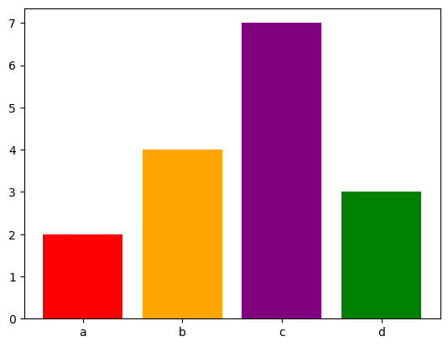
The color parameter, however, can also take in an array of strings, where each string represents a color. Below, we use a Python list to specify the colors for four bars — note that Matplotlib preserves the order of colors in the list:

colors = ['red', 'orange', 'purple', 'green']
plt.bar(['a', 'b', 'c', 'd'], [2, 4, 7, 3],
color=colors)
plt.show()

For our data, it can get cumbersome to manually add the color code for each correlation value. We're going to simplify this using pandas — below are the steps for the white wine data set:
- We calculate the correlations betweenqualityand the other columns.
- We create a Boolean vector where zero and positive correlation values are mapped toTrue, and negative values are mapped toFalse.
- We map each Boolean value to a string representing a color code:Trueto'#33A1C9', andFalseto'#ffae42'.

white_corr = white_wine.corr()['quality'][:-1]
positive_white = white_corr >= 0
color_map_white = positive_white.map({True:'#33A1C9',
False:'#ffae42'}
)

color_map_white

fixed acidity #ffae42
volatile acidity #ffae42
citric acid #ffae42
residual sugar #ffae42
chlorides #ffae42
free sulfur dioxide #33A1C9
total sulfur dioxide #ffae42
density #ffae42
pH #33A1C9
sulphates #33A1C9
alcohol #33A1C9
Name: quality, dtype: object

A pandasSeriesis also an array, which means we can passcolor_map_whiteto thecolorparameter.
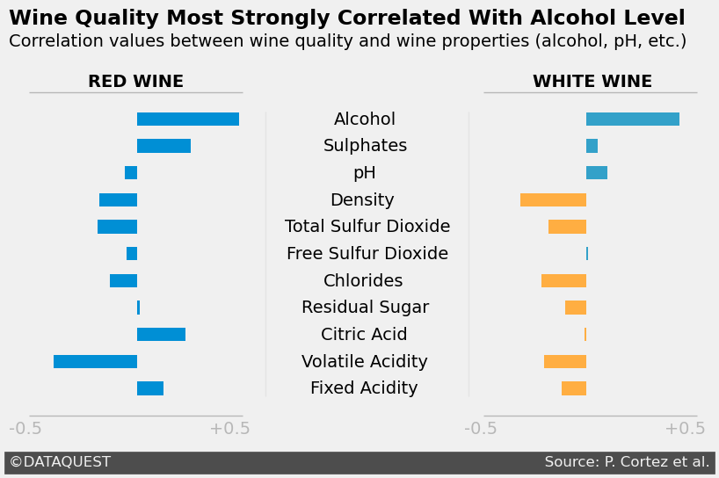
# Assume the rest of the code is written
ax.barh(white_corr.index, white_corr, color=color_map_white,
height=0.5, left=2)

Now, let's follow the same steps for the red wine bar plot.
Instructions

positive_white = white_corr >= 0
color_map_white = positive_white.map({True:'#33A1C9', False:'#ffae42'})

positive_red = red_corr >= 0
color_map_red = positive_red.map({True:'#33A1C9', False:'#ffae42'})

style.use('fivethirtyeight')
fig, ax = plt.subplots(figsize=(9, 5))
ax.barh(white_corr.index, white_corr, left=2, height=0.5,
color=color_map_white)

ax.barh(red_corr.index, red_corr, height=0.5, left=-0.1,
color=color_map_red)

ax.grid(b=False)
ax.set_yticklabels([])
ax.set_xticklabels([])

x_coords = {'Alcohol': 0.82, 'Sulphates': 0.77, 'pH': 0.91,
'Density': 0.80, 'Total Sulfur Dioxide': 0.59,
'Free Sulfur Dioxide': 0.6, 'Chlorides': 0.77,
'Residual Sugar': 0.67, 'Citric Acid': 0.76,
'Volatile Acidity': 0.67, 'Fixed Acidity': 0.71}
y_coord = 9.8

for y_label, x_coord in x_coords.items():
ax.text(x_coord, y_coord, y_label)
y_coord -= 1

ax.axvline(0.5, c='grey', alpha=0.1, linewidth=1,
ymin=0.1, ymax=0.9)
ax.axvline(1.45, c='grey', alpha=0.1, linewidth=1,
ymin=0.1, ymax=0.9)

ax.axhline(-1, color='grey', linewidth=1, alpha=0.5,
xmin=0.01, xmax=0.32)
ax.text(-0.7, -1.7, '-0.5'+ ' '*31 + '+0.5',
color='grey', alpha=0.5)

ax.axhline(-1, color='grey', linewidth=1, alpha=0.5,
xmin=0.67, xmax=0.98)
ax.text(1.43, -1.7, '-0.5'+ ' '*31 + '+0.5',
color='grey', alpha=0.5)

ax.axhline(11, color='grey', linewidth=1, alpha=0.5,
xmin=0.01, xmax=0.32)
ax.text(-0.33, 11.2, 'RED WINE', weight='bold')

ax.axhline(11, color='grey', linewidth=1, alpha=0.5,
xmin=0.67, xmax=0.98)
ax.text(1.75, 11.2, 'WHITE WINE', weight='bold')

ax.text(-0.7, -2.9, '©DATAQUEST' + ' '*92 + 'Source: P. Cortez et al.',
color = '#f0f0f0', backgroundcolor = '#4d4d4d',
size=12)

ax.text(-0.7, 13.5,
'Wine Quality Most Strongly Correlated With Alcohol Level',
size=17, weight='bold')
ax.text(-0.7, 12.7,
'Correlation values between wine quality and wine properties (alcohol, pH, etc.)')

plt.show()

- Create a pandasSeriesfor the red wine data set to specify the color order.
  - The correlation values are already saved inred_corr.
  - Zero and positive correlation values should have the color code'#33A1C9'.
  - Negative correlation values should have the color code'#ffae42'.
- Use theSeriesyou've just created to change the colors of the bars in the red wine bar plot.

positive_white = white_corr >= 0
color_map_white = positive_white.map({True:'#33A1C9', False:'#ffae42'})

positive_red = red_corr >= 0
color_map_red = positive_red.map({True:'#33A1C9', False:'#ffae42'})

style.use('fivethirtyeight')
fig, ax = plt.subplots(figsize=(9, 5))
ax.barh(white_corr.index, white_corr, left=2, height=0.5,
color=color_map_white)

ax.barh(red_corr.index, red_corr, height=0.5, left=-0.1,
color=color_map_red)

ax.grid(b=False)
ax.set_yticklabels([])
ax.set_xticklabels([])

x_coords = {'Alcohol': 0.82, 'Sulphates': 0.77, 'pH': 0.91,
'Density': 0.80, 'Total Sulfur Dioxide': 0.59,
'Free Sulfur Dioxide': 0.6, 'Chlorides': 0.77,
'Residual Sugar': 0.67, 'Citric Acid': 0.76,
'Volatile Acidity': 0.67, 'Fixed Acidity': 0.71}
y_coord = 9.8

for y_label, x_coord in x_coords.items():
ax.text(x_coord, y_coord, y_label)
y_coord -= 1

ax.axvline(0.5, c='grey', alpha=0.1, linewidth=1,
ymin=0.1, ymax=0.9)
ax.axvline(1.45, c='grey', alpha=0.1, linewidth=1,
ymin=0.1, ymax=0.9)

ax.axhline(-1, color='grey', linewidth=1, alpha=0.5,
xmin=0.01, xmax=0.32)
ax.text(-0.7, -1.7, '-0.5'+ ' '*31 + '+0.5',
color='grey', alpha=0.5)

ax.axhline(-1, color='grey', linewidth=1, alpha=0.5,
xmin=0.67, xmax=0.98)
ax.text(1.43, -1.7, '-0.5'+ ' '*31 + '+0.5',
color='grey', alpha=0.5)

ax.axhline(11, color='grey', linewidth=1, alpha=0.5,
xmin=0.01, xmax=0.32)
ax.text(-0.33, 11.2, 'RED WINE', weight='bold')

ax.axhline(11, color='grey', linewidth=1, alpha=0.5,
xmin=0.67, xmax=0.98)
ax.text(1.75, 11.2, 'WHITE WINE', weight='bold')

ax.text(-0.7, -2.9, '©DATAQUEST' + ' '*92 + 'Source: P. Cortez et al.',
color = '#f0f0f0', backgroundcolor = '#4d4d4d',
size=12)

ax.text(-0.7, 13.5,
'Wine Quality Most Strongly Correlated With Alcohol Level',
size=17, weight='bold')
ax.text(-0.7, 12.7,
'Correlation values between wine quality and wine properties (alcohol, pH, etc.)')

plt.show()

8.Next steps
In this lesson, we learned about Matplotlib styles. We focused on thefivethirtyeightstyle and managed to build quite a nice graph.
Next, we'll practice what we learned by working on a guided project.

